Ashcon Abae

Signals and Systems

12 November 2019

Homework #3

1. To compute the Fourier series coefficients, let’s consider the case when T=2:  
   This would mean that $ω_{0}=\frac{2π}{T}=π$  
   Next, we can write $$a_{k}=\frac{1}{T}\int_{0}^{2}{x\left(t\right)e^{-jkω_{0}t}dt} \\ =\frac{1}{2}\int_{0}^{2}{\left[δ\left(t\right)-2δ\left(t-1\right)\right]e^{-jkω_{0}t}} \\ =\frac{1}{2}\left[e^{-jkω_{0}\left(0\right)}-2e^{-jkω_{0}\left(1\right)}\right] \\ =\frac{1}{2}\left[1-2e^{-jkω_{0}}\right] \\ =\frac{1}{2}\left[1-2e^{-jkπ}\right]→e^{-jkπ}={\left(-1\right)}^{k} \\ a_{k}=\frac{1}{2}\left[1-2{\left(-1\right)}^{k}\right]$$ 
   Plugging the numbers found in the given periodic signal, we have: $$a_{0}=-\frac{1}{2} \\ a_{1}=\frac{3}{2} \\ a_{-1}=\frac{3}{2} \\ a_{2}=-\frac{1}{2} \\ a_{-2}=-\frac{1}{2} \\ a_{3}=\frac{3}{2} \\ a_{-3}=\frac{3}{2}$$ 
   Finally, we can plot ak:  
   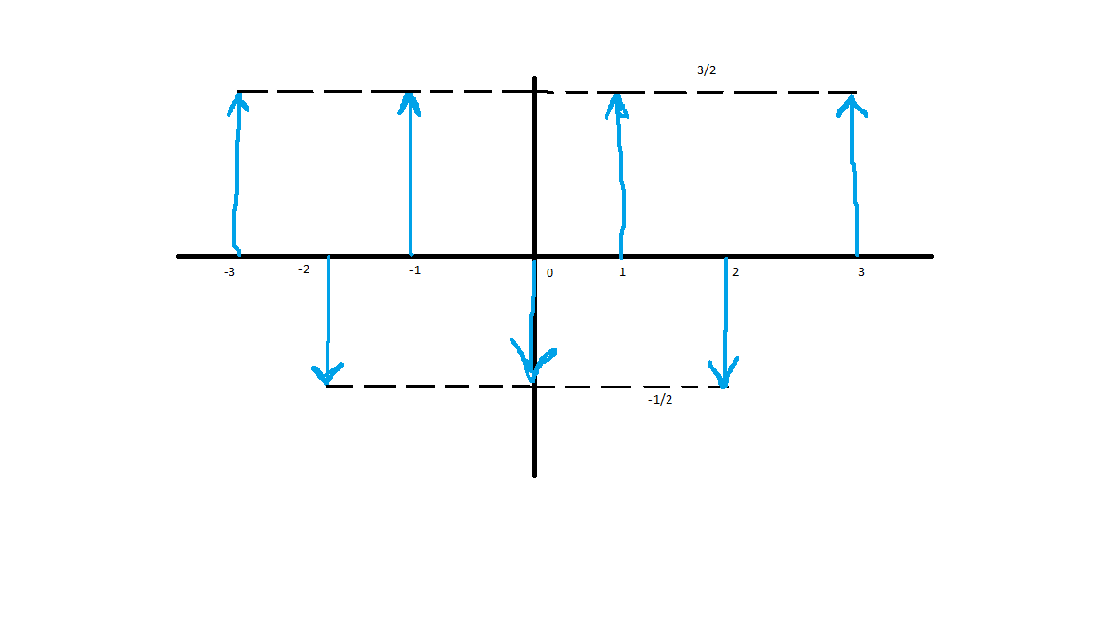
   1. In a periodic signal, our Fourier transform will be: $$x\left(ω\right)=\int_{-∞}^{∞}{x\left(t\right)e^{-jωt}dt} \\ =\int_{-∞}^{∞}{e^{at}u\left(-t\right)e^{-jωt}dt} \\ =\int_{0}^{∞}{e^{at}e^{-jωt}dt} \\ ={\left.\left[\frac{1}{a-jω}\right]e^{\left(a-jω\right)t}\right|}_{t=0}^{t=∞} \\ =\frac{1}{a-jω}\left[e^{\left(a-jω\right)\left(∞\right)}-e^{-\left(a-jω\right)\left(0\right)}\right] \\ =\frac{1}{a-jω}\left[e^{a∞}*e^{-jω∞}-e^{0}\right] \\ =\frac{1}{a-jω}\left[0-1\right] \\ x\left(ω\right)=\frac{1}{a-jω}$$
   2. $x\left(t\right)=-u\left(t+1\right)+2u\left(t\right)-u\left(t-1\right)$ In a periodic signal, our Fourier transform will be: $$x\left(ω\right)=\int_{-∞}^{∞}{x\left(t\right)e^{-jωt}dt} \\ =\int_{-∞}^{∞}{\left(-u\left(t+1\right)+2u\left(t\right)-u\left(t-1\right)\right)\left(e^{-jωt}\right)dt} \\ =\int_{-∞}^{∞}{-u\left(t+1\right)\left(e^{-jωt}\right)dt}+\int_{-∞}^{∞}{2u\left(t\right)\left(e^{-jωt}\right)dt}-\int_{-∞}^{∞}{u\left(t-1\right)\left(e^{-jωt}\right)dt} \\ =-\left[\frac{e^{jω}}{jω}\right]+2\left[\frac{1}{jω}\right]-\left[\frac{e^{-jω}}{jω}\right] \\ =\left[\frac{-e^{jω}}{jω}-\frac{e^{-jω}}{jω}\right]+\frac{2}{jω} \\ =\frac{2e^{-jω}}{jω}-\frac{2e^{jω}}{jω} \\ =\frac{2e^{jω}+2e^{-jω}}{2} \\ =\frac{2}{jω}-\frac{2e^{jω}}{2}+\frac{2e^{-jω}}{2}$$ 
      Because $\frac{e^{jω}+e^{-jω}}{2}=\cos{ω}$, we can write the above as: $$\frac{2}{jω}-\frac{2}{jω}\left[\cos{ω}\right] \\ =\frac{2}{jω}-\frac{2}{jω}\left[1-2{\sin\left(\frac{ω}{2}\right)}^{2}\right] \\ =\frac{4{\sin\left(\frac{ω}{2}\right)}^{2}}{jω} \\ =\frac{2\sin{\frac{ω}{2}}}{j}*\frac{\sin{\frac{ω}{2}}}{\frac{ω}{2}} \\ =\frac{2}{j}\sin{\frac{ω}{2}}\operatorname{sinc}{\frac{ω}{2}}$$
   3. If f(t) is a band-limited signal with bandwidth 300 Hz, that would mean that f(t) would begin at t=f and would end at t=f+300, for a total bandwidth of 300 Hz. That is, (f+300) – (f) = 300 Hz. Thus, f(2t) would be a band-limited signal that would begin at $t=\frac{f}{2}$ and end at $t=\frac{f+300}{2}$. Therefore, f(2t)’s bandwidth would be $\frac{f+300}{2}-\frac{f}{2}=\frac{300}{2}=150$ Hz. Thus, statement a of the original problem is true.
   4. False. If function x(t) is real and either even or odd, then its Fourier transform $x(ω)$ is also real and either even or odd. Given that x(t) is real in the original problem, then its Fourier transform would indeed be real, but it would be either even or odd, depending on which one the original x(t) is. There is insufficient information to determine with 100% accuracy that the Fourier transform $x(ω)$ would be real & even, therefore this statement is false.
   5. Given $x\left(t\right)=\cos{2t}$. Based on this we can say that $ω_{0}=2$. Here, the convolution of h(t) with $\cos{ω_{0}t}$ corresponds to the output of a system with impulse response and input. But $h\left(t\right)*\cos\left(ω_{0}t\right)=\left|H\left(ω_{0}\right)\right|\cos\left(ω_{0}t+∠H\left(ω_{0}\right)\right)$, where H is the Fourier transform of h(t). Thus the statement is only true when it is equal to $A\cos\left(2t-θ\right)$, therefore this statement is false.
2. **Question 7.3 from Textbook**
   1. Given $x\left(t\right)=1+\cos\left(2000πt\right)+\sin\left(4000πt\right)$. The Nyquist rate will be equal to twice the highest frequency in the signal. Looking back at original problem, we can see that our highest frequency in the signal is . So our Nyquist rate can be expressed as follows:
   2. Given . The Nyquist rate will be equal to twice the highest frequency in the signal. Looking back at original problem, we can see that our highest frequency in the signal is . So our Nyquist rate can be expressed as follows:
   3. Given . The Nyquist rate will be equal to twice the highest frequency in the signal. Looking back at original problem, we can see that our highest frequency in the signal is $ω_{max}=8000π$. So our Nyquist rate can be expressed as follows: $$ω_{n}=2*ω_{max}=2*8000π=16000π$$
3. Let’s consider the signal x(t) and impulse train: $$p\left(t\right)=\sum_{n=-∞}^{∞}{δ\left(t-nT\right)} \\ x_{p}\left(t\right)=x\left(t\right)*p\left(t\right) \\ x_{p}\left(t\right)=\sum_{n=-∞}^{∞}{x(t)δ\left(t-nT\right)}$$ 
   From the sampling theorem, we can rewrite $x_{p}\left(ω\right)=\frac{1}{T}\sum_{n=-∞}^{∞}{x\left(ω-nω_{s}\right)}$, where $x(ω)$ is the Fourier transform of x(t).  
   For the signal $$x\left(t\right)=\cos\left(2πf_{0}t+θ\right)=\cos\left(ω_{0}t+θ\right)$$ 
   The Fourier transform can be expressed as $$x\left(ω\right)=π\left[δ\left(ω-ω_{0}\right)+δ\left(ω+ω_{0}\right)\right]$$ 
   1. Given $f_{0}=250 Hz, θ=\frac{π}{4}$ $$ω_{0}=2πf_{0}=2π\left(250 Hz\right)=500π\frac{rad}{sec} \\ ω_{s}=2πf_{s}=\frac{2π}{T}=\frac{2π}{1E-3}=2000π\frac{rad}{sec}$$ 
      Next, lets calculate $$x_{p}\left(ω\right)=\frac{1}{T}\sum_{n=-∞}^{∞}{x\left(ω-nω_{s}\right)} \\ ={10}^{3}\sum_{n=-∞}^{∞}{x\left(ω-n2000π\right)}$$ 
      Where $x\left(ω\right)=π\left[δ\left(ω-500π\right)+δ\left(ω+500π\right)\right]$  
      Let’s consider the case when n=0: $$x_{p}\left(ω\right)={10}^{3}x\left(ω\right)$$ 
      For n=1: $$x_{p}\left(ω\right)={10}^{3}x\left(ω-2000π\right)$$ 
      For n=2: $$x_{p}\left(ω\right)={10}^{3}x\left(ω-4000π\right)$$ 
      If we add all the spectrum components for $x_{p}\left(ω\right)$ and pass it as the signal through the low pass filter, we will get $$x_{r}\left(ω\right)=x_{p}\left(ω\right)H\left(ω\right) \\ →x_{r}\left(ω\right)=π\left[δ\left(ω-500π\right)+δ\left(ω+500π\right)\right] \\ x_{r}\left(t\right)=\cos\left(ω_{0}t+θ\right) \\ x_{r}\left(t\right)=\cos\left(500πt+\frac{π}{4}\right)$$ 
      Next, we can solve for the sampling frequency $$ω_{s}=2πf_{s}=\frac{2π}{T}=\frac{2π}{{10}^{-3}}=2000π$$ 
      Since $2000π>1000π$, (that is $ω_{s}>2ω_{0}$), there is no aliasing effect.
   2. Given $f_{0}=750 Hz, θ=\frac{π}{2}$ $$ω_{0}=2πf_{0}=2π\left(750 Hz\right)=1500π\frac{rad}{sec}$$ 
      We previously solved $$x_{p}(ω)={10}^{3}\sum_{n=-∞}^{∞}{x\left(ω-n2000π\right)}$$ 
      Using this and the previous calculations, we can input our new frequency and phase angle to solve $$x_{r}\left(t\right)=\cos\left(1500πt+\frac{π}{2}\right)=-\sin\left(1500πt\right)$$
   3. Given $f_{0}=500 Hz, θ=\frac{π}{2}$ $$ω_{0}=2πf_{0}=2π\left(500 Hz\right)=1000π\frac{rad}{sec}$$ 
      Using this and the previous calculations we’ve done, we can input our new frequency and phase angle to solve $$x_{r}\left(t\right)=2cos\left(1000πt+\frac{π}{2}\right)=-2\sin\left(1000πt\right)$$
   4. By applying Laplace transform, we can write: $$\left(s+1\right)y\left(s\right)=\left(s-1\right)x\left(s\right) \\ →H\left(s\right)=\frac{y\left(s\right)}{x\left(s\right)}=\frac{s-1}{s+1}$$ 
        
      So for $x_{1}\left(s\right)=\frac{1}{s+1}$, we can express: $$y\left(s\right)=\frac{s-1}{{\left(s+1\right)}^{2}}=\frac{s+1}{{\left(s+1\right)}^{2}}-\frac{2}{{\left(s+1\right)}^{2}}=\frac{1}{s+1}-\frac{2}{{\left(s+1\right)}^{2}} \\ →y\left(t\right)=\left[e^{-t}-2te^{-t}\right]u(t)$$
   5. Similar to part a, we can write: $$H\left(s\right)=\frac{y\left(s\right)}{w\left(s\right)}=\frac{kG}{1+kG}=\frac{k\left(\frac{s-1}{s+1}\right)}{1+k\left(\frac{s-1}{s+1}\right)} \\ =\frac{k\left(s-1\right)}{s+1+ks-k}=\frac{k\left(s-1\right)}{s\left(1+k\right)+\left(1-k\right)} \\ y\left(s\right)\left\{s\left(1+k\right)\right\}+y\left(s\right)\left(1-k\right)=w\left(s\right)\left(k\left(s-1\right)\right) \\ →\left(k+1\right)\frac{dy}{dt}+y\left(t\right)\left(1-k\right)=k\frac{dw(t)}{dt}-w(t)$$
   6. The values of K for which the closed loop feedback system from part b is stable can be expressed as: $$s\left(k+1\right)+\left(1-k\right)≥0 \\ →k<1$$
   7. Given $X\left(z\right)=\frac{1}{\left(1-\frac{1}{2}z^{-1}\right)\left(1-z^{-1}\right)}$  
      Let’s express the given equation in terms of z and not z-1:
   8. Let’s consider our z transform expressed in terms of z and not z-1, as we solved in part a: $$X\left(z\right)=\frac{z^{2}}{\left(z-\frac{1}{2}\right)\left(z-1\right)} \\ \frac{X\left(z\right)}{z}=\frac{z}{\left(z-\frac{1}{2}\right)\left(z-1\right)}$$ 
      Using the partial fraction expansion, we can simplify $\frac{X\left(z\right)}{z}$: $$\frac{X\left(z\right)}{z}=\frac{z}{\left(z-\frac{1}{2}\right)\left(z-1\right)}=\frac{A}{z-\frac{1}{2}}+\frac{B}{z-1} \\ →\frac{z}{\left(z-\frac{1}{2}\right)\left(z-1\right)}=\frac{A\left(z-1\right)+B\left(z-\frac{1}{2}\right)}{\left(z-\frac{1}{2}\right)\left(z-1\right)} \\ →z=A\left(z-1\right)+B\left(z-\frac{1}{2}\right)$$ 
      Next, we solve for A by substituting ½ for z: $$\frac{1}{2}=A\left(\frac{1}{2}-1\right)+B\left(0\right) \\ →\frac{1}{2}=A\left(-\frac{1}{2}\right) \\ →A=-1$$ 
      Then, we solve for B by substituting 1 for z: $$1=A\left(0\right)+B\left(1-\frac{1}{2}\right) \\ →1=B\left(\frac{1}{2}\right) \\ →B=2$$ 
      Finally, we can substitute A and B back into our equation: $$\frac{X\left(z\right)}{z}=\frac{A}{z-\frac{1}{2}}+\frac{B}{z-1} \\ \frac{X\left(z\right)}{z}=\frac{-1}{z-\frac{1}{2}}+\frac{2}{z-1} \\ →X\left(z\right)=\frac{-z}{z-\frac{1}{2}}+\frac{2z}{z-1}$$ 
      Therefore, X(z) as a sum of terms can be expressed as $$X\left(z\right)=\frac{-z}{z-\frac{1}{2}}+\frac{2z}{z-1}$$
   9. From the above 2 parts, we can say that the poles of X(z) are ½ and 1.  
      Thus, the possible ROCs are: $$\left|z\right|<\frac{1}{2} \\ \frac{1}{2}<\left|z\right|<1 \\ \left|z\right|>1$$ 
      For $\left|z\right|<\frac{1}{2}$, the signal is left sided.  
      For $\frac{1}{2}<\left|z\right|<1$, the signal is 2 sided.  
      For $\left|z\right|>1$, the signal is right sided.  
      Next, we apply the inverse z-transform to X(z):  
      Because x[n] is a left sided sequence, The ROC of X(z) should also be left sided. Thus, the ROC is $\left|z\right|<\frac{1}{2}$. Our ROC $\left|z\right|<\frac{1}{2}$ is overlapping of $\left|z\right|<\frac{1}{2}$ and $\left|z\right|<1$. Next, let’s consider the z-transform pairs: $$\frac{1}{1-az^{-1}}↔-a^{n}u\left[-n-1\right] ; \left|z\right|<\left|a\right| \left(left sided signal\right) \\ \frac{1}{1-\frac{1}{2}z^{-1}}↔-{\left(\frac{1}{2}\right)}^{n}u\left[-n-1\right] ; \left|z\right|<\frac{1}{2} \left(left sided signal\right) \\ \frac{1}{1-z^{-1}}↔-u\left[-n-1\right] ; \left|z\right|<1 \left(left sided signal\right)$$ 
      Thus, $$x\left[n\right]=-z^{-1}\left[\frac{1}{1-\frac{1}{2}z^{-1}}\right]+2z^{-1}\left[\frac{1}{1-z^{-1}}\right] \\ =-\left[-{\left(\frac{1}{2}\right)}^{n}u\left[-n-1\right]\right]-2u\left[-n-1\right] \\ ={\left(\frac{1}{2}\right)}^{n}u\left[-n-1\right]-2u\left[-n-1\right] \\ x[n]=\left[{\left(\frac{1}{2}\right)}^{n}-2\right]u[-n-1]$$